**ADJ BANKING SOFTWARE**

1. **Introduction**

ADJ Banking Software maintains client’s bank accounts and providing basic banking services such as deposit, withdraw, and change PIN. The group tried to recreate a real-life banking management services by providing a Python application of such which consist of two main parts: The administrative module and the ATM module. The administrative module is used and accessed by the System Administrators or Bank Tellers. It has the following functionalities: To open, close accounts and view account information. In opening accounts, the new account will be added to the database system. In closing accounts, an existing account will be deleted in the database. In view account information, an account number is required to be entered to view the particular account. On the other hand, the ATM module side can be used by the client in order to do deposit, withdraw, balance inquiry, or change pin transaction. First, the user must be authenticated by putting his/her card number (ATM card insertion in real-life ATM) together with the PIN number. All except balance inquiry will update the database after execution. In summary, the administrative module has open close account functionalities while ATM module has deposit, withdraw, change pin and check balance transaction.

1. **Objectives**

* To be able to implement a banking management software using Python programming by providing an application that can offer basic bank transactions.
* To be able to utilize SQLite as the database management system of the software.

1. **Functions**

**Administrator**

* Open Account - the new account will be added to the database system.
* Close Account - an existing account will be deleted in the database.
* View Account - an account number is required to be entered to view the particular account.

**Client (ATM MODULE)**

* Deposit – prompts the user to enter the desired amount to be deposited.
* Withdraw - prompts the user to enter the desired amount to be withdrawn.
* Balance inquiry – Displays the current balance of the user as determined in the SQLite database.
* Change Pin transaction – Requires the user to enter a new pin number. Reentering the new pin number is also required to make sure that the entered pin is the correct desired pin.

1. **Graphical User Interface**

**Admin UI**

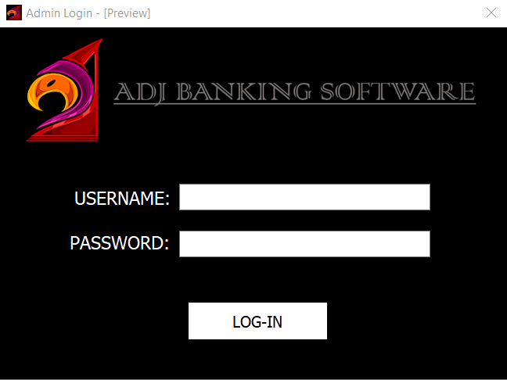

*Login Page (Administrator)*

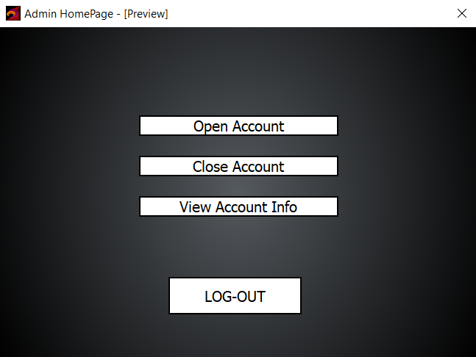

*Homepage (Administrator)*

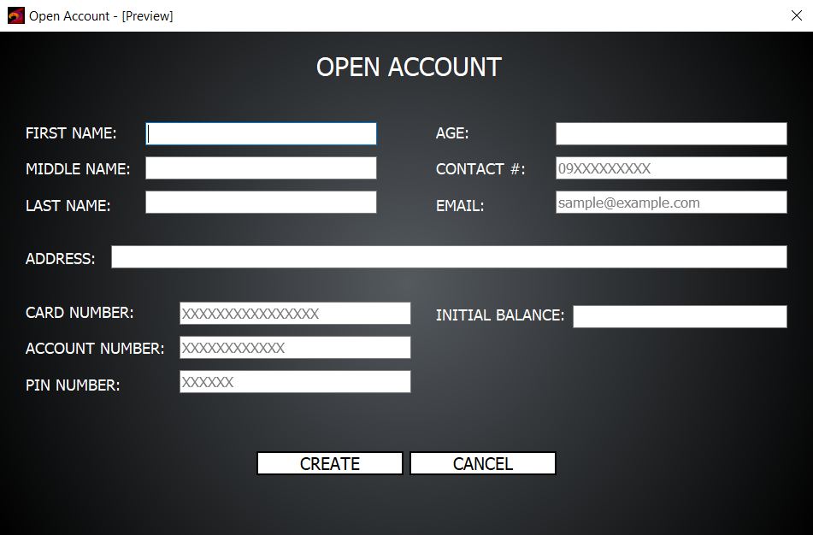

*Open Account (Administrator)*

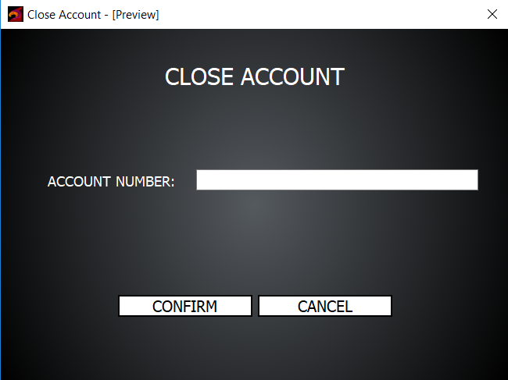

*Close Account (Administrator)*

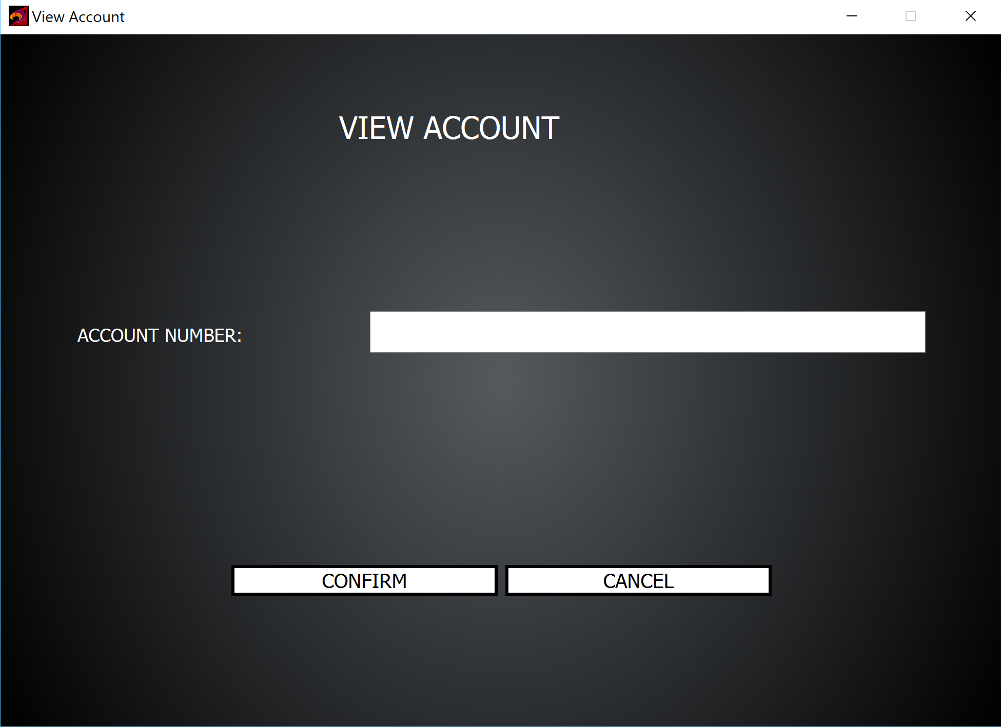

*View Account (Administrator)*

1. **Use Case Diagram**

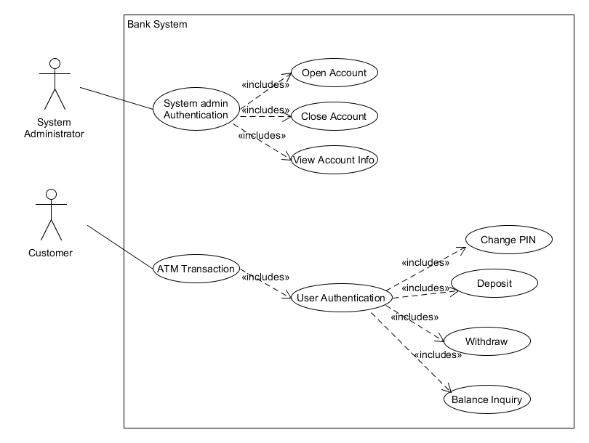

The Use Case diagram above is the representation of the overall banking services of the software. It consists of two actors (system administrator, customer). Each actor own sets of functionalities represented by the ovals (use case). The system administrator is prompt for authentication before being able to open, close and view account info as well as the customer before giving the choices of transaction.

1. **Class Diagram**

**Conceptual**

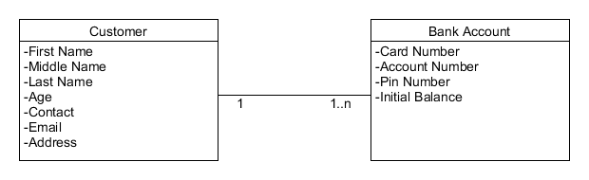

The diagram above is in a business level type of representation. The following class names are only related to the real class names in the future codes are not necessarily the names to be implemented in the programming. Customer has the following attributes which will correspond to the attributes in the Bank Account.

**Detailed**

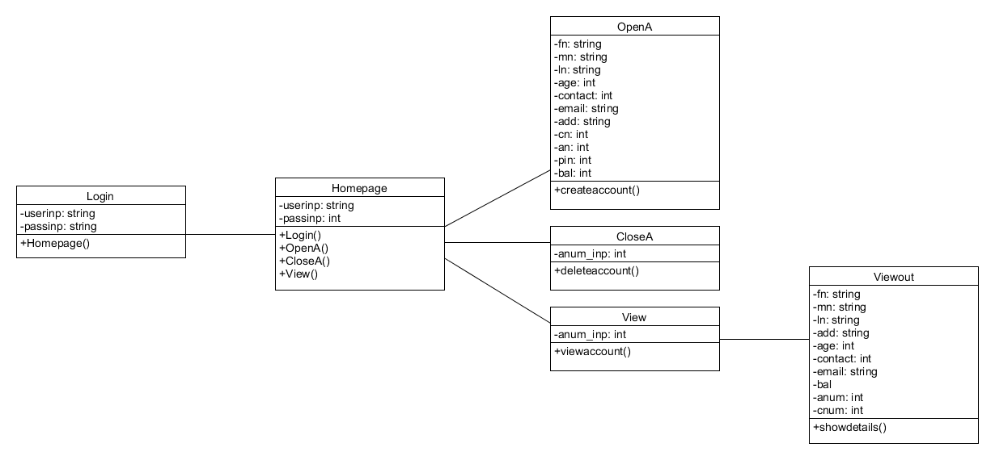

Detailed as the name suggest is a class diagram composed of classes with attributes included with data types and methods. The administrator side has 4 methods( Login(), OpenA(), CloseA(), ViewA() that can be accessed only after authentication from the Login class. In order to avoid confusion “A” was included at the end of each class names to indicate that it is in the administrator side. Mostly the “string” and “integer” datatypes were needed for the whole diagram.

1. **Test Case Diagram**

|  |  |  |  |  |  |
| --- | --- | --- | --- | --- | --- |
| TC#1 – Creating an Account | | | | | |
| TC_ID# | Test Objective | Precondition | Steps | Test Data | Expected Result |
| TC_A1 | Authenticate System Administrator | System is on and displaying a login page | Input system admin username and password |  | System displays system administrator homepage |
| TC_A2 | System rejects system admin username/password | System is on and displaying a login page | Input invalid system admin username and password |  | System displays an error screen and is ready to start a new session |
| TC_A3 | System allows system admin to choose Create account option | The user must be logged-in as System Administrator | Choose Create account option |  | System displays Create account option session |
| TC_A4 | Create non-existing account | Create account session is displayed | 1. Type-in user details  2. Type-in account details of non-existing account |  | System displays User account successfully created and goes back to homepage |
| TC_A5 | Create existing account | Create account session is displayed | 1. Type-in user details  2. Type-in account details of existing account |  | System prompts User account already existed |

|  |  |  |  |  |  |
| --- | --- | --- | --- | --- | --- |
| TC#2 – Closing an Account | | | | | |
| TC_ID# | Test Objective | Precondition | Steps | Test Data | Expected Result |
| TC_B1 | Authenticate System Administrator | System is on and displaying a login page | Input system admin username and password |  | System displays system administrator homepage |
| TC_B2 | System rejects system admin username/password | System is on and displaying a login page | Input invalid system admin username and password |  | System displays an error screen and is ready to start a new session |
| TC_B3 | System allows system admin to choose Close account option | The user must be logged-in as System Administrator | Choose Close account option |  | System displays Close account option session |
| TC_B4 | Close existing account | Close account session is displayed | Enter valid account# |  | System displays User account successfully closed and goes back to homepage |
| TC_B5 | Close non-existing account | Close account session is displayed | Enter invalid account# |  | System displays an error screen and is prompt to enter again |

|  |  |  |  |  |  |
| --- | --- | --- | --- | --- | --- |
| TC#3 – View Account Info | | | | | |
| TC_ID# | Test Objective | Precondition | Steps | Test Data | Expected Result |
| TC_C1 | Authenticate System Administrator | System is on and displaying a login page | Input system admin username and password |  | System displays system administrator homepage |
| TC_C2 | System rejects system admin username/password | System is on and displaying a login page | Input invalid system admin username and password |  | System displays an error screen and is ready to start a new session |
| TC_C3 | System allows system admin to choose View Account Info | The user must be logged-in as System Administrator | Choose View Account Info option |  | System displays View Account Info session |
| TC_C4 | View existing user account info | View Account Info session is displayed | Enter account# |  | System displays User account info successfully and goes back to homepage |
| TC_C5 | View non-existing user account info | View Account Info session is displayed | Enter invalid account# |  | System displays an error screen and is prompt to enter again |

|  |  |  |  |  |  |
| --- | --- | --- | --- | --- | --- |
| TC#4 – ATM Transaction (Deposit) | | | | | |
| TC_ID# | Test Objective | Precondition | Steps | Test Data | Expected Result |
| TC_D1 | System authenticates the user | System is on and displaying a login page | Insert card (user card#) and PIN |  | System displays a menu of transaction types |
| TC_D2 | System rejects invalid user card (card#)/PIN | System is on and displaying a login page | Insert invalid card (user card#) and PIN |  | System displays an error screen and is ready to start a new session |
| TC_D3 | Customer exceeds max number of invalid PIN tries (3 entries) and system aborts session | System is on and displaying a login page | Enter 3rd try ofinvalid PIN |  | System displays an error screen and session is terminated |
| TC_D4 | System allows customer to perform a Deposit transaction | Menu of transaction types is being displayed | Choose Deposit transaction |  | System displays the Deposit transaction session |
| TC_D5 | System allows customer to enter a peso amount to deposit | System is displaying a request for the customer to type a peso amount | Enter a legitimate peso amount |  | System prints receipt showing amount and updated balance |
| TC_D6 | System allows multiple transactions in one session | System is asking whether customer wants another transaction | Choose yes |  | System displays a menu of transaction types |
| TC_D7 | Session ends when customer chooses not to do another transaction | System is asking whether customer wants another transaction | Choose no |  | System terminates and is ready to start a new session |

|  |  |  |  |  |  |
| --- | --- | --- | --- | --- | --- |
| TC#5 – ATM Transaction (Withdrawal) | | | | | |
| TC_ID# | Test Objective | Precondition | Steps | Test Data | Expected Result |
| TC_E1 | System authenticates the user | System is on and displaying a login page | Insert card (user card#) and PIN |  | System displays a menu of transaction types |
| TC_E2 | System rejects invalid user card (card#)/PIN | System is on and displaying a login page | Insert invalid card (user card#) and PIN |  | System displays an error screen and is ready to start a new session |
| TC_E3 | Customer exceeds max number of invalid PIN tries (3 entries) and system aborts session | System is on and displaying a login page | Enter 3rd try ofinvalid PIN |  | System displays an error screen and session is terminated |
| TC_E4 | System allows customer to perform a Withdrawal transaction | Menu of transaction types is being displayed | Choose Withdrawal transaction |  | System displays the Withdrawal transaction session |
| TC_E5 | System verifies that customer's balance is sufficient to fulfill the request | System is displaying a request for the customer to type a peso amount | Choose an amount that is not greater than the account balance |  | System prints receipt showing amount and updated balance |
| TC_E6 | System verifies that customer's balance is insufficient to fulfill the request | System is displaying a request for the customer to type a peso amount | Choose an amount that is greater than the account balance |  | System displays an appropriate message and asks customer to choose a different amount |
| TC_E7 | System verifies that customer's withdrawal amount is greater than per transaction limit amount (10000Php) | System is displaying a request for the customer to type a peso amount | Choose an amount that is greater than per transaction limit amount |  | System displays an appropriate message and asks customer to choose a different amount |
| TC_E8 | System allows multiple transactions in one session | System is asking whether customer wants another transaction | Choose yes |  | System displays a menu of transaction types |
| TC_E9 | Session ends when customer chooses not to do another transaction | System is asking whether customer wants another transaction | Choose no |  | System terminates and is ready to start a new session |

|  |  |  |  |  |  |
| --- | --- | --- | --- | --- | --- |
| TC#6 – ATM Transaction (Balance Inquiry) | | | | | |
| TC_ID# | Test Objective | Precondition | Steps | Test Data | Expected Result |
| TC_F1 | System authenticates the user | System is on and displaying a login page | Insert card (user card#) and PIN |  | System displays a menu of transaction types |
| TC_F2 | System rejects invalid user card (card#)/PIN | System is on and displaying a login page | Insert invalid card (user card#) and PIN |  | System displays an error screen and is ready to start a new session |
| TC_F3 | Customer exceeds max number of invalid PIN tries (3 entries) and system aborts session | System is on and displaying a login page | Enter 3rd try ofinvalid PIN |  | System displays an error screen and session is terminated |
| TC_F4 | System allows customer to perform a Balance Inquiry transaction | Menu of transaction types is being displayed | Choose Balance Inquiry transaction |  | System prints receipt showing balance |
| TC_F5 | System allows multiple transactions in one session | System is asking whether customer wants another transaction | Choose yes |  | System displays a menu of transaction types |
| TC_F6 | Session ends when customer chooses not to do another transaction | System is asking whether customer wants another transaction | Choose no |  | System terminates and is ready to start a new session |

|  |  |  |  |  |  |
| --- | --- | --- | --- | --- | --- |
| TC#7 – ATM Transaction (Change PIN) | | | | | |
| TC_ID# | Test Objective | Precondition | Steps | Test Data | Expected Result |
| TC_G1 | System authenticates the user | System is on and displaying a login page | Insert card (user card#) and PIN |  | System displays a menu of transaction types |
| TC_G2 | System rejects invalid user card (card#)/PIN | System is on and displaying a login page | Insert invalid card (user card#) and PIN |  | System displays an error screen and is ready to start a new session |
| TC_G3 | Customer exceeds max number of invalid PIN tries (3 entries) and system aborts session | System is on and displaying a login page | Enter 3rd try ofinvalid PIN |  | System displays an error screen and session is terminated |
| TC_G4 | System allows customer to perform Change PIN | Menu of transaction types is being displayed | Choose Change PIN |  | System displays the Change PIN session |
| TC_G5 | System verifies that customer's new PIN is valid | System is displaying a request for the customer to enter new PIN | Enter valid new PIN |  | System prompts the customer that current PIN is successfully changed |
| TC_G6 | System verifies that customer's new PIN is the same as old PIN | System is displaying a request for the customer to enter new PIN | Enter invalid or old PIN |  | System displays an appropriate message and asks customer to choose a different PIN |
| TC_G7 | System verifies that customer's new PIN is not the same with re-entered PIN | System is displaying a request for the customer to enter new PIN | Enter valid new PIN different with re-entered PIN |  | System displays an appropriate message and asks customer to re-enter the same PIN |
| TC_G8 | System allows multiple transactions in one session | System is asking whether customer wants another transaction | Choose yes |  | System displays a menu of transaction types |
| TC_G9 | Session ends when customer chooses not to do another transaction | System is asking whether customer wants another transaction | Choose no |  | System terminates and is ready to start a new session |

1. **Partial Codes**
2. **Sprint 1**

* main.py
* res.py
* admin_log.py
* admin_hp.py
* admin_open.py
* admin_close.py
* admin_view.py
* admin_viewout.py
* admin_prompt.py
* admin_prompt2.py
* admin_error.py
* admin_error2.py

1. **Sprint 2**
2. **Sprint 3**
3. **Summary of Daily Scrum**

|  |  |
| --- | --- |
| **Date** | **Summary** |
| 9/21/18 | The banking software was introduced as well as the parts. Tasks were assigned to be accomplished such as: Use case, Test Case, and Burn Down Chart. |
| 9/22/18 | Previous tasks were fulfilled and new tasks were distributed to the members. The next tasks were focusing on the graphical user interface of the administrator side. |
| 9/23/18 | Updated Burn down Chart progress. Submitted graphical user interface for the admin side was acknowledged by the scrum master. Proceeding to code for the admin side, tasks were distributed. The team decided to create a logo for the software. CSV file was opted for temporary data storage. |
| 9/24/18 | Coding tasks were in progress and to be completed before the next scrum. |
| 9/25/18 | Submitted files were acknowledged. Proceeding on compilation of codes and creation of preliminary database. |

1. **Recommendation**
2. **Conclusion**